**SQL QUERIES FOR PIZZA SALES**

**A.KPI’S**

**1.Total revenue**

SELECT sum(total_price) AS TOTAL_REVENUE FROM pizza_sales;



**2.Average order Value**

SELECT (SUM(total_price) / COUNT(DISTINCT order_id)) AS Avg_order_Value

FROM pizza_sales;



**3.Total Pizza sold**

SELECT sum(quantity) as total_pizza_sold FROM pizza_sales



**4.Total orders**

SELECT count(DISTINCT order_id) as total_orders

FROM pizza_sales



**5.The average number of pizzas sold per order**

SELECT CAST(sum(quantity) as REAL (10,2)) / CAST(count(DISTINCT order_id) as REAL (10,2)) as avg_pizzas_per_order

FROM pizza_sales



**B. Daily Trend for Total Orders**

SELECT

CASE strftime('%w', substr(order_date, 7, 4) || '-' || substr(order_date, 4, 2) || '-' || substr(order_date, 1, 2))

WHEN '0' THEN 'Sunday'

WHEN '1' THEN 'Monday'

WHEN '2' THEN 'Tuesday'

WHEN '3' THEN 'Wednesday'

WHEN '4' THEN 'Thursday'

WHEN '5' THEN 'Friday'

WHEN '6' THEN 'Saturday'

END AS order_day,

COUNT(DISTINCT order_id) AS total_orders

FROM pizza_sales

GROUP BY order_day;

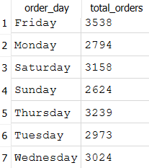

**C. Hourly Trend for Orders**

SELECT

strftime('%H', order_time) AS order_hours,

COUNT(DISTINCT order_id) AS total_orders

FROM pizza_sales

GROUP BY order_hours

ORDER BY order_hours;

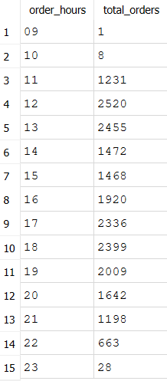

**D. % of Sales by Pizza Category**

SELECT

pizza_category,

ROUND(SUM(total_price), 2) AS category_sales,

ROUND(SUM(total_price) * 100.0 / (SELECT SUM(total_price) FROM pizza_sales ), 2) AS percentage_of_sales

FROM pizza_sales

GROUP BY pizza_category

ORDER BY percentage_of_sales DESC;

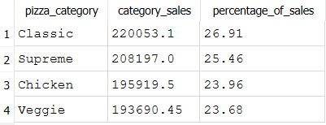

**E. % of Sales by Pizza Size**

SELECT

pizza_size,

ROUND(SUM(total_price), 2) AS category_sales,

ROUND(SUM(total_price) * 100.0 / (SELECT SUM(total_price) FROM pizza_sales ), 2) AS percentage_of_sales

FROM pizza_sales

GROUP BY pizza_size

ORDER BY percentage_of_sales DESC;

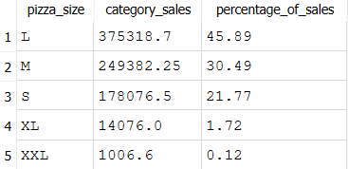

**F. Total Pizzas Sold by Pizza Category**

SELECT

pizza_category,

SUM(quantity) AS total_pizzas_sold

FROM pizza_sales

GROUP BY pizza_category

ORDER BY total_pizzas_sold DESC;

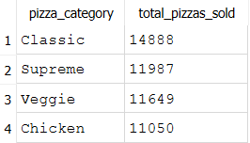

**G. Top 5 Best Sellers by Total Pizzas Sold**

SELECT

pizza_name,

SUM(quantity) AS total_sold

FROM pizza_sales

GROUP BY pizza_name

ORDER BY total_sold DESC

LIMIT 5;

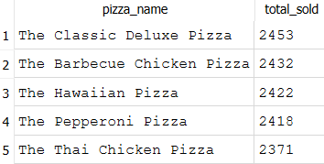

**H. Bottom 5 Best Sellers by Total Pizzas Sold**

SELECT

pizza_name,

SUM(quantity) AS total_sold

FROM pizza_sales

GROUP BY pizza_name

ORDER BY total_sold DESC

LIMIT 5;

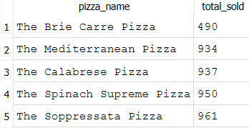

**NOTES**

Percentage of Sales by Pizza Category for January (dd/mm/yyyy format)

SELECT

pizza_category,

ROUND(SUM(total_price), 2) AS category_sales,

ROUND(SUM(total_price) * 100.0 / (

SELECT SUM(total_price)

FROM pizza_sales

WHERE SUBSTR(order_date, 4, 2) = '01'

), 2) AS percentage_of_sales

FROM pizza_sales

WHERE SUBSTR(order_date, 4, 2) = '01'

GROUP BY pizza_category

ORDER BY percentage_of_sales DESC;

**EXCEL**

* **CHANGED THE PIZAA NAME SIZES**
* **ADDED A NEW COLUMN AS ORDER_DAY AND THE FORMULA USED TO GET DATA INTO IT IS**

**=TEXT([@[order_date]],"dddd")**

* **CREATED A SUM OF TOAL_PRICE USING PIVOT TABLE**
* **CREATED A NEW COLUMN NAMED TOTAL_ORDERS USING THE FORMULA**

**=1/COUNTIF(B:B,[@[order_id]]) I CREATED A DISTINCT COUNT USING THIS FORMULA**

* **AVG ORDER VALUE = TOTAL REVENUE / TOTAL NO. OF ORDERS**
* **I DID SUM OF QUANTITY TO GET THE TOTAL NO OF PIZZAS**
* **AVG PIZZAS PER ORDER TOTAL NO PIZZAS/ TOTAL ORDERS**